**DOCKER ASSIGNMENT :- HTTPD IMAGE & INDEX FILE DEPLOYMENT USING JENKINS D-PIPELINE**

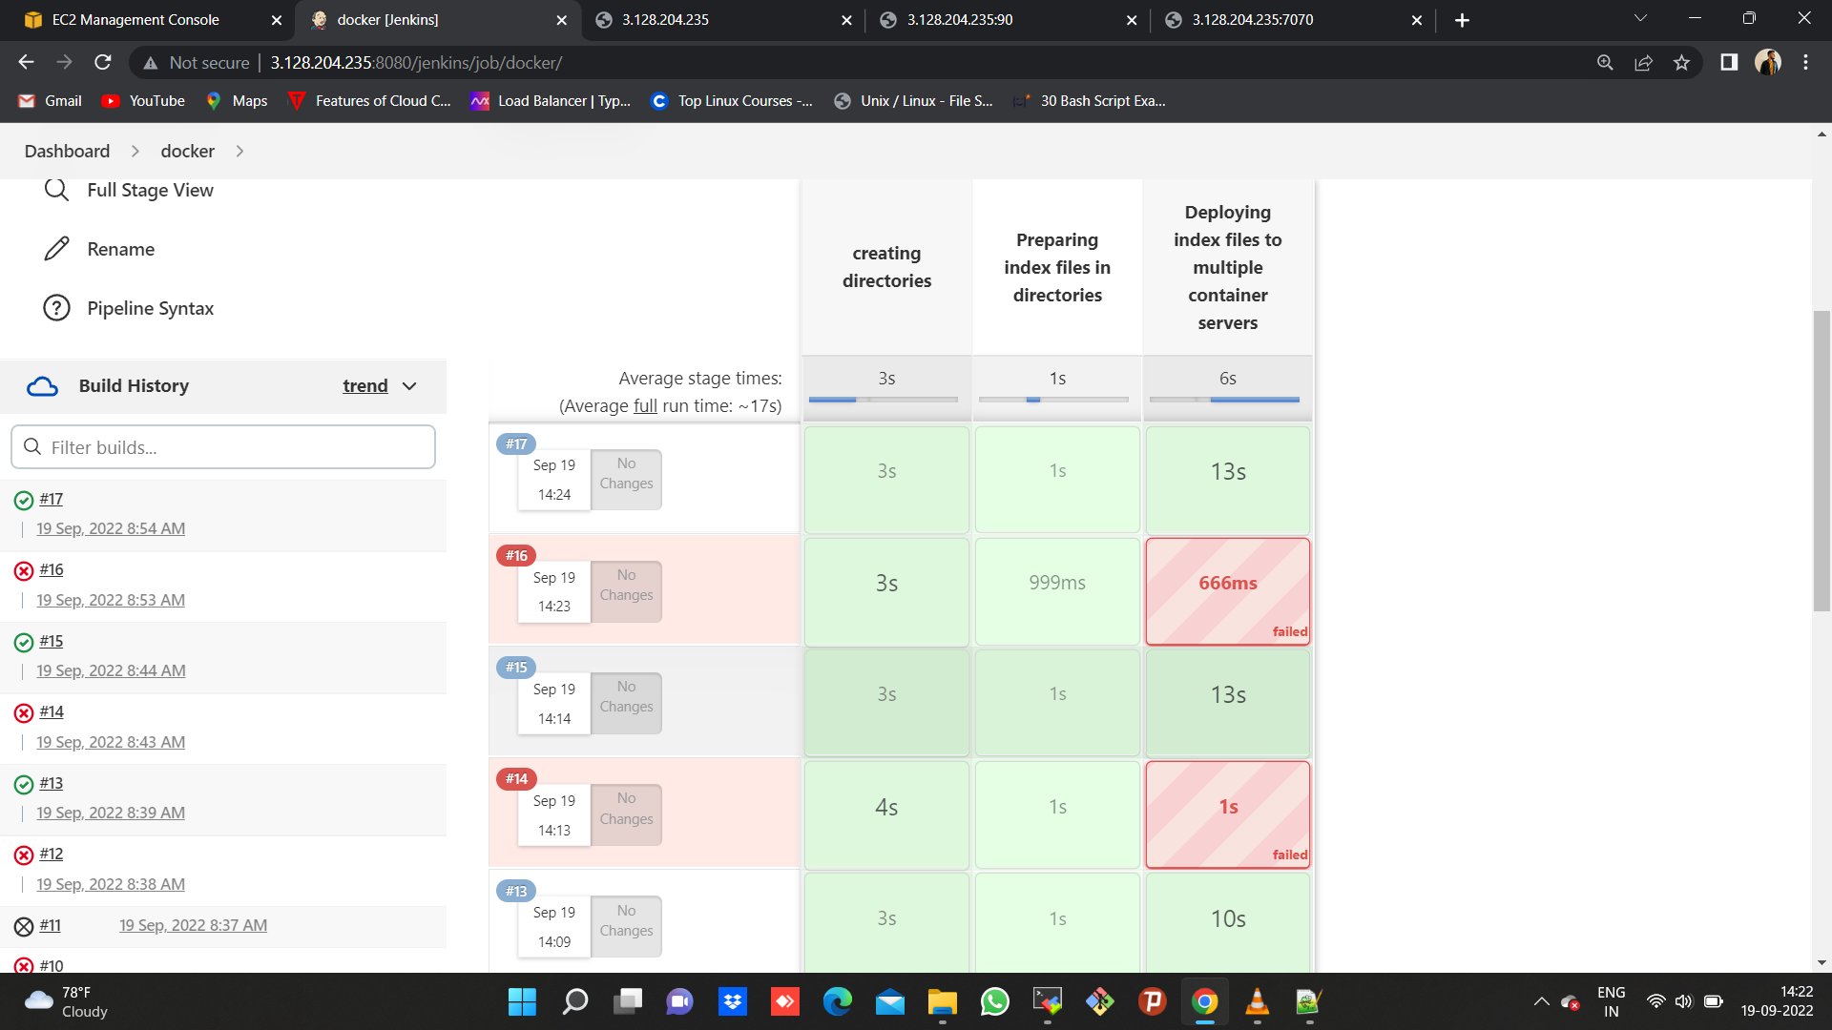

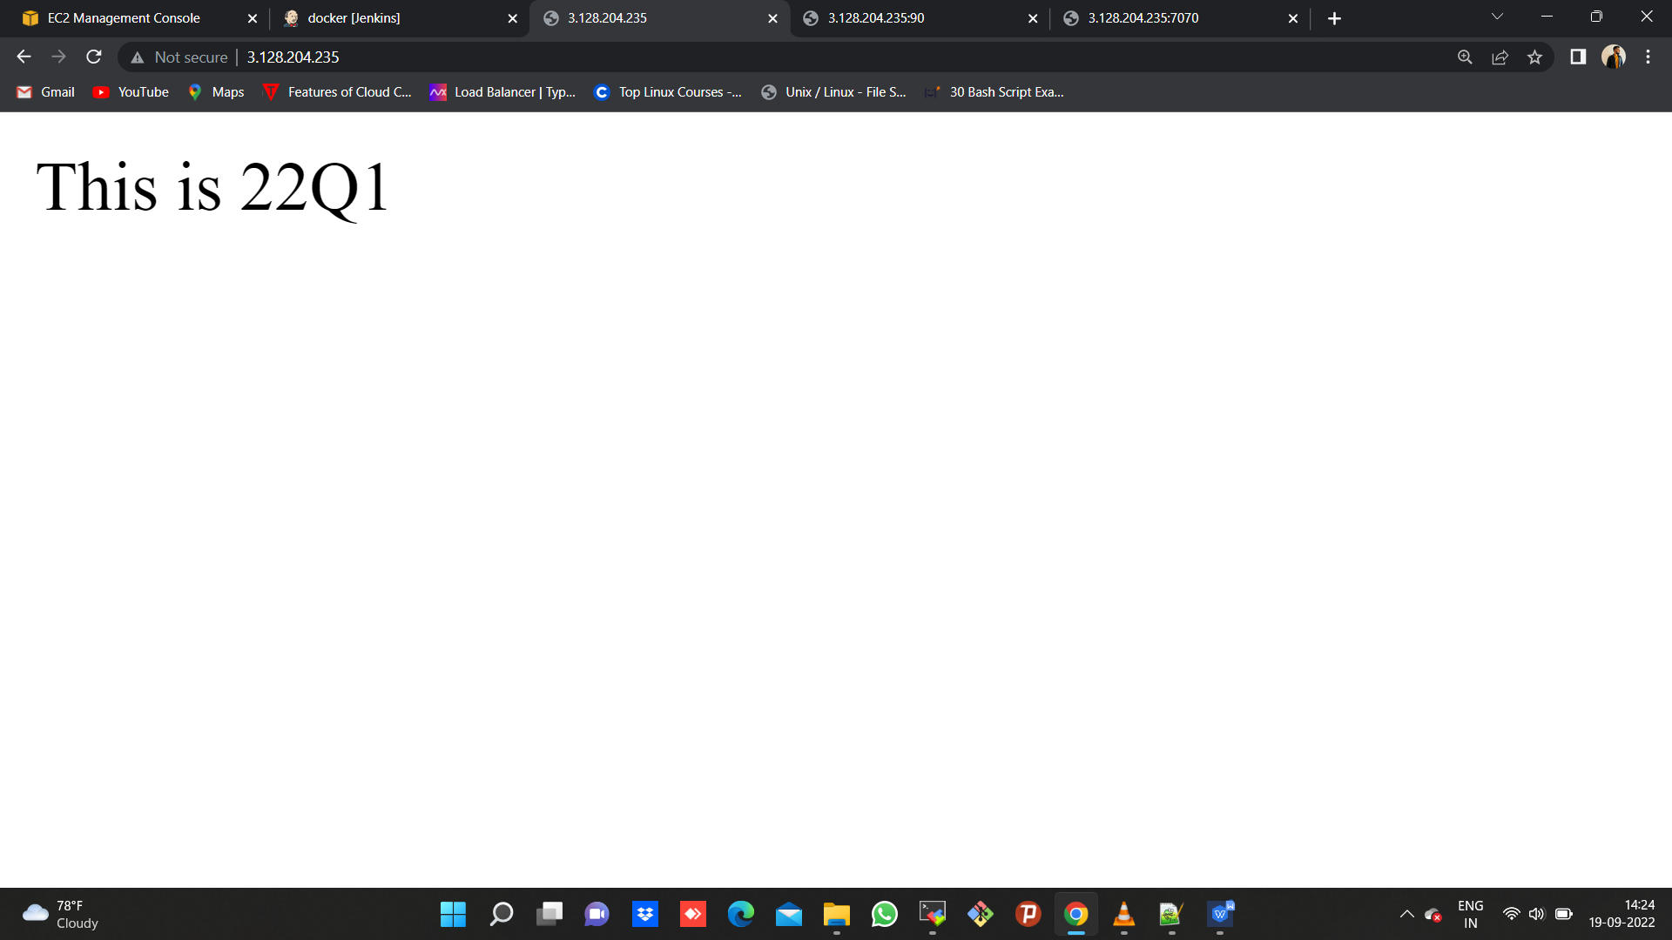

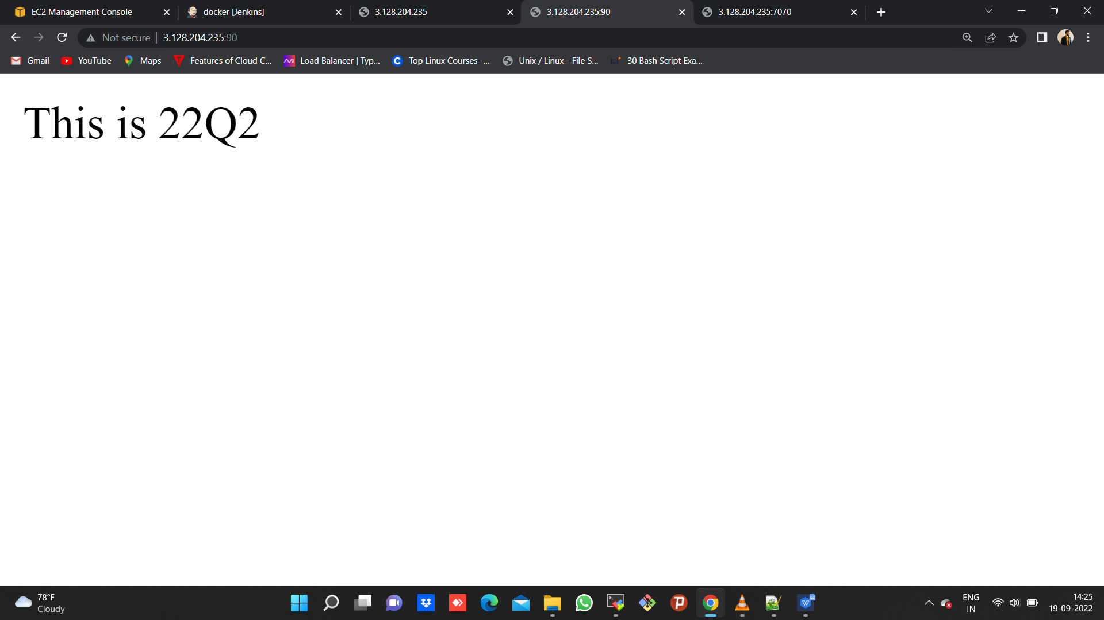

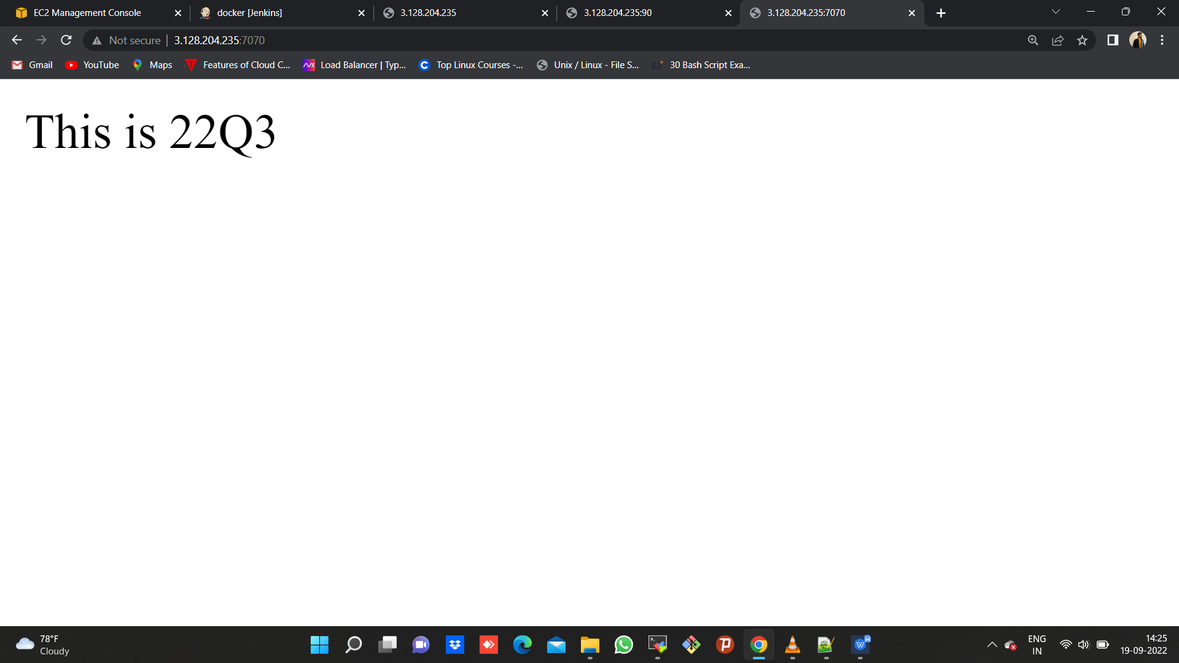

**CODE:**

pipeline {

agent {

label{

label "built-in"

customWorkspace "/mnt"

}

}

stages {

stage ('creating directories'){

steps {

sh "rm -rf 22Q1 22Q2 22Q3"

sh "chmod -R 777 /mnt"

sh "mkdir 22Q1 22Q2 22Q3"

sh "yum install docker -y"

sh "systemctl start docker"

}

}

stage ('Preparing index files in directories') {

steps {

dir ('22Q1') {

sh "echo 'This is 22Q1' >> index.html"

}

dir ('22Q2') {

sh "echo 'This is 22Q2' >> index.html"

}

dir ('22Q3') {

sh "echo 'This is 22Q3' >> index.html"

}

}

}

stage ('Deploying index files to multiple container servers') {

steps {

dir ('22Q1') {

sh "docker stop server-1 server-2 server-3" //keep this line commented for first build//

sh "docker system prune -a -f"

sh "docker run --name server-1 -itdp 80:80 httpd" //run image through a custom-name so that you can use the same while copying, no need to use container ID//

sh "chmod 777 index.html"

sh "docker cp index.html server-1:/usr/local/apache2/htdocs"

}

dir ('22Q2') {

sh "docker run --name server-2 -itdp 90:80 httpd" //run image through a custom-name so that you can use the same while copying, no need to use container ID//

sh "chmod 777 index.html"

sh "docker cp index.html server-2:/usr/local/apache2/htdocs"

}

dir ('22Q3') {

sh "docker run --name server-3 -itdp 7070:80 httpd" //run image through a custom-name so that you can use the same while copying, no need to use container ID//

sh "chmod 777 index.html"

sh "docker cp index.html server-3:/usr/local/apache2/htdocs"

}

}

}

}

}